Credit Card Authorization Release Form
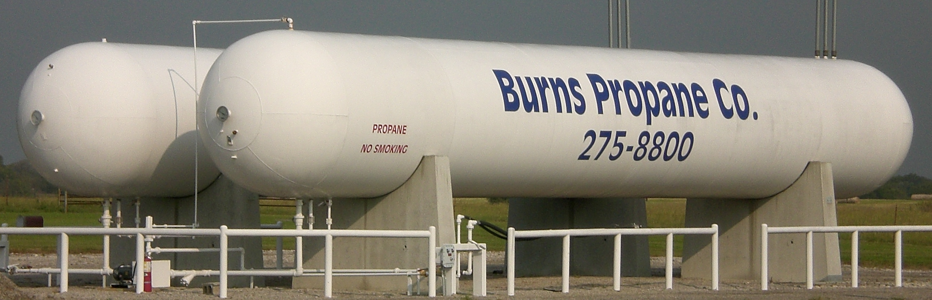

burns propane company
8800 S Hwy 169
P.O. Box 288
Oologah, OK 74053
USA
Phone (918) 275-8800
(918)273-0887
Fax (918) 275-8826
E-mail burnspropane@yahoo.com
Web site http://www.burnspropane.com

Credit Card Information (circle one): Visa Mastercard American Express Discover

Credit Card Number: ___________________________________________ Exp. Date: __________

3 or 4 digit security code on back of card: _________________

Billing Information

Cardholder’s Name __________________________________________________________________

Cardholder’s Billing Address ___________________________________________________________
City: _________________________ State: _________Zip: _______________

Phone (Home): ______________________ CELL: _____________________ FAX: ________________

EMAIL (for receipt):

I, ____________________________________________________ (name of card owner or officer), authorize BURNS PROPANE COMPANY to charge the above credit card for:

(Choose one) All Deliveries/Rental Charges Monthly Budget Only Other (Explain below)

Other: _________________________________________________________________________________________ ________________________________________________________________________________________________

And I guarantee payment for any purchases made with the credit card account number identified above, including renewed cards.

______________________________________________________ __________________________
Signature of Cardholder Date

